DIGITAL FORENSICS FINAL LAB EXAM2023S-BCYS-OO6
NABIHA ADNAN KHAN
BS CYBER SECURITY (5TH SEMESTER)
DIGITAL FORENSICS
FLAG 1:- 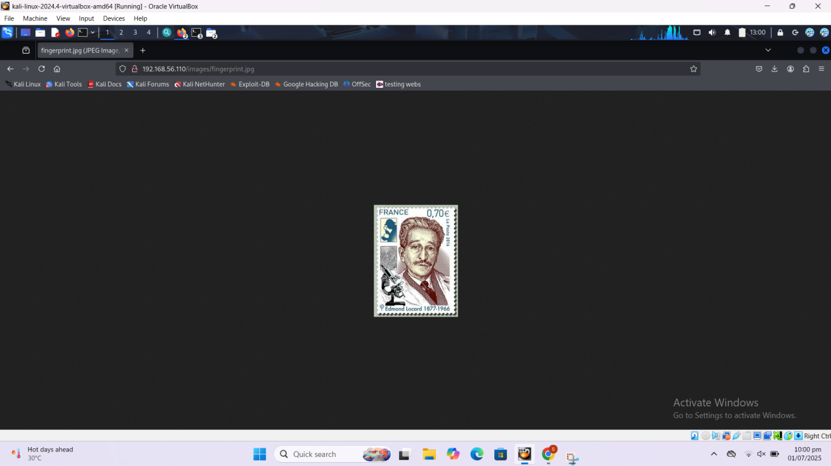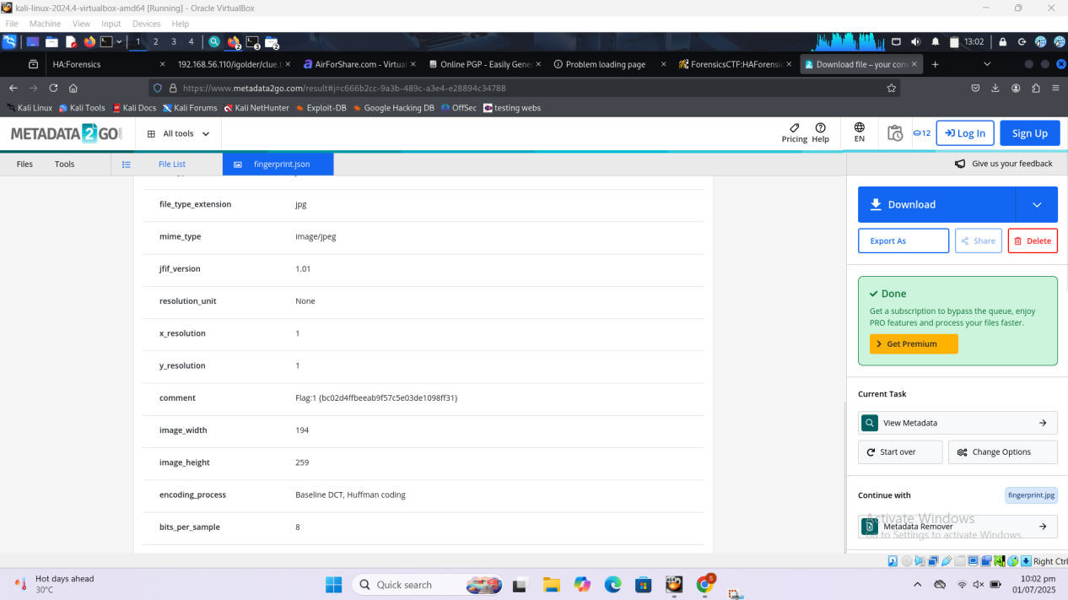
The flag is achieved by directory brute forcing. After finding and exploring the directory/image there was a fingerprint.jpg stag file, so took outs its metadata and inside it was the flag.

FLAG 2:-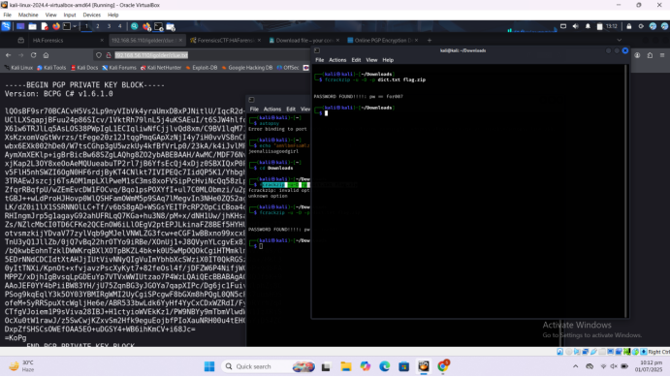
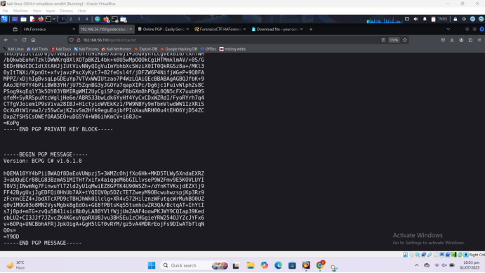
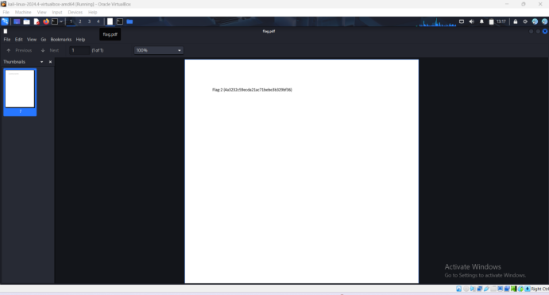
This flag is achieved by finding the .txt file through directory brute forcing. There was a flag.zip file. After unzipping it and cracking its password through dictionary attack. Through its name flag 2 was found.

FLAG 3:-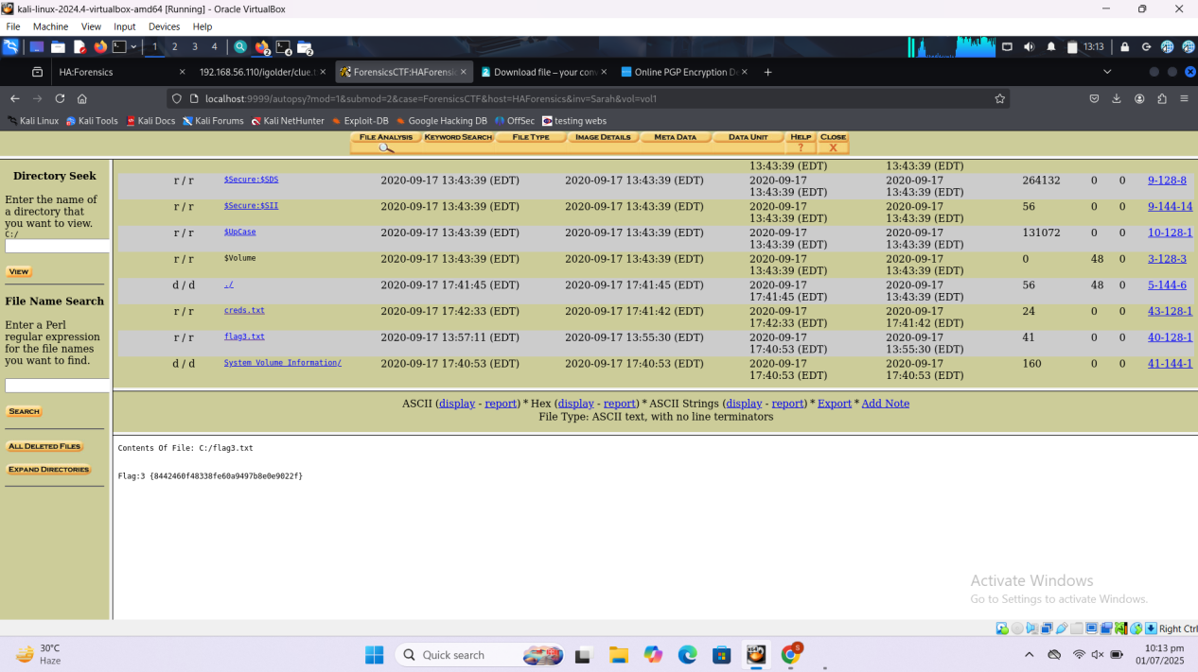
For achieving flag 3 we we enumerated through metasploit and run the exploits and found saboot.txt which we hosted on server and downloaded it . After downloading put it in autopsy so flag 3 was found.

FLAG 4:-

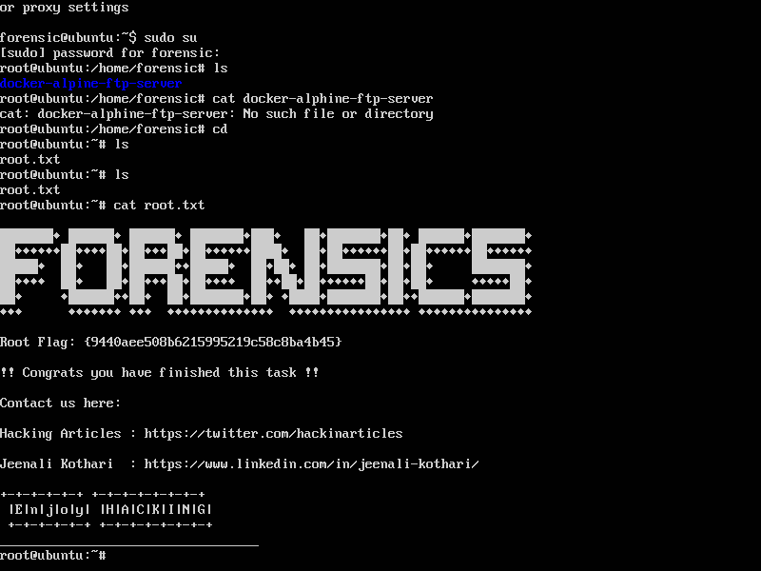
For flag 4 I just boot the Vulnhub vm provided and set it to root and then put ls command and found root.txt fle which we opened the data of it through cat command there flag 4 was found.

